


Your guide to
NDIS funding


Why this guide?

Abbeena is here to help every single Australian in the NDIS find their way around the NDIS more easily.
That’s why our team of NDIS experts and plan managers created this pocket-size guide which translates all the NDIS jargon into easy to understand language.
This guide will help you to understand the difference between Core, Capacity Building and Capital Supports and what each category’s funds can be used for.
If you have any questions afterwards, we are here to help on 02) 7245 2777

Don’t forget, anything you buy with NDIS funding needs to be ‘reasonable & necessary’
How do you know which therapies, services or products qualify for NDIS funding under the ‘reasonable and necessary’ rule? See if you can answer ‘yes’ to all of the following questions:
- Is this a product or service you need due to a disability?

- Does it help you meet your plan’s goals?

- Is it reasonable value for money?

- Is there evidence for it to work?

- Is it a support you wouldn’t be able to receive from family or a community member?
- Is the NDIS the most suitable funding scheme to pay for this support?

Core Supports Capacity Building Supports Capital Supports

Core supports
This is funding you receive to help you with daily activities. It is flexible: You can use it across all four categories in this core bucket. Transport tends to be
separate where periodic payments are made into your nominated bank account.

Assistance with Daily Activities
 Assistance with daily personal activities: personal hygiene, moving around the home
 Assistance with household tasks: cleaning, yard maintenance
 Preparation of meals, laundry service (must be stated supports in your plan)

 Assistance in Supported Independent Living

Consumables
 Continence products
 Low-cost assistive technology (‘AT’) for prosthetics and orthotics
 Low-cost AT for personal care & safety
 Low-cost AT for mobility
 Low-cost AT for communication (comms apps)
 Interpreting and translation

Assistance with social & community participation
 Access to community, social and recreational activities such as art classes, sports, camps, library visits or day trips
 Group and centre-based activities
 Specialised employment supports

Transport
 Alternatives to public transport due to disability e.g. taxis, Ubers, fuel, specialised transport

Core Supports Capacity Building Supports Capital Supports

Capacity Building Supports
This is funding you receive to build your independence and skills. It is semi-flexible: you can use this funding freely within each category below, but not across categories in this bucket.

Improved Daily Living Skills
 Occupational Therapy, Psychology, Speech Pathogy, Physiotherapy, Exercise Physiology
 Individual or group counselling
 Training for carers & parents
 Assistance with decision making, daily planning and budgeting
 Individual skills development and training
 Early childhood intervention, specialised group early intervention

Increased social and community participation
 Individual skills development and training e.g. attending a community camp or vacation group to build social & communication skills
 Community participation activities
 Innovative community participation
 Life transition planning including mentoring, peer support, individual skill development

Improved health and wellbeing
 Dietician consultation and diet planning
 Dietician group session
 Personal training

Improved relationships
 Specialised behaviour intervention support
 Training in behaviour management strategies

Core Supports Capacity Building Supports Capital Supports

Support Coordination
 Connection to supports
 Assistance in coordinating or managing life stages, transitions, and supports
 Linking participants to mainstream and informal supports

 Building capacity of participants
 Psychosocial recovery coaching

Improved Life Choices
 Plan management services
 Plan & financial capacity building
 Learning self-management

Finding and keeping a job
 Employment-related assessment & counselling
 Assistance in specialised supported employment
 Individual employment support
 Support in employment (ADE)
 School leaver employment supports

Improved Living Arrangements
 Assistance with accommodation and tenancy obligations

Improved Learning
 Help to research and apply for study and training opportunities
 Won’t cover tuition fees

Core Supports Capacity Building Supports Capital Supports

Capital Supports
This is funding to help you pay for more expensive big-ticket items and services. You can only use it for the specific purpose stated in your plan and nothing else.

Assistive Technology

 Communication technology
 Hearing technology
 Vision equipment
 Mobility products (lifts, hoists, sit-to-stand chairs)
 Wheelchairs and related items
 Orthotics
 Prostheses
 Adapted furniture
 Assistance animals
 Environmental control systems

Home Modifications
 Elevators
 Ramps
 Slip-resistant coating on surfaces
 Other custom-built modifications
 Certification to approve home modifcations
 Consultations with builders
 Professionals like project managers or building certifiers
 Specialist Disability Accommodation


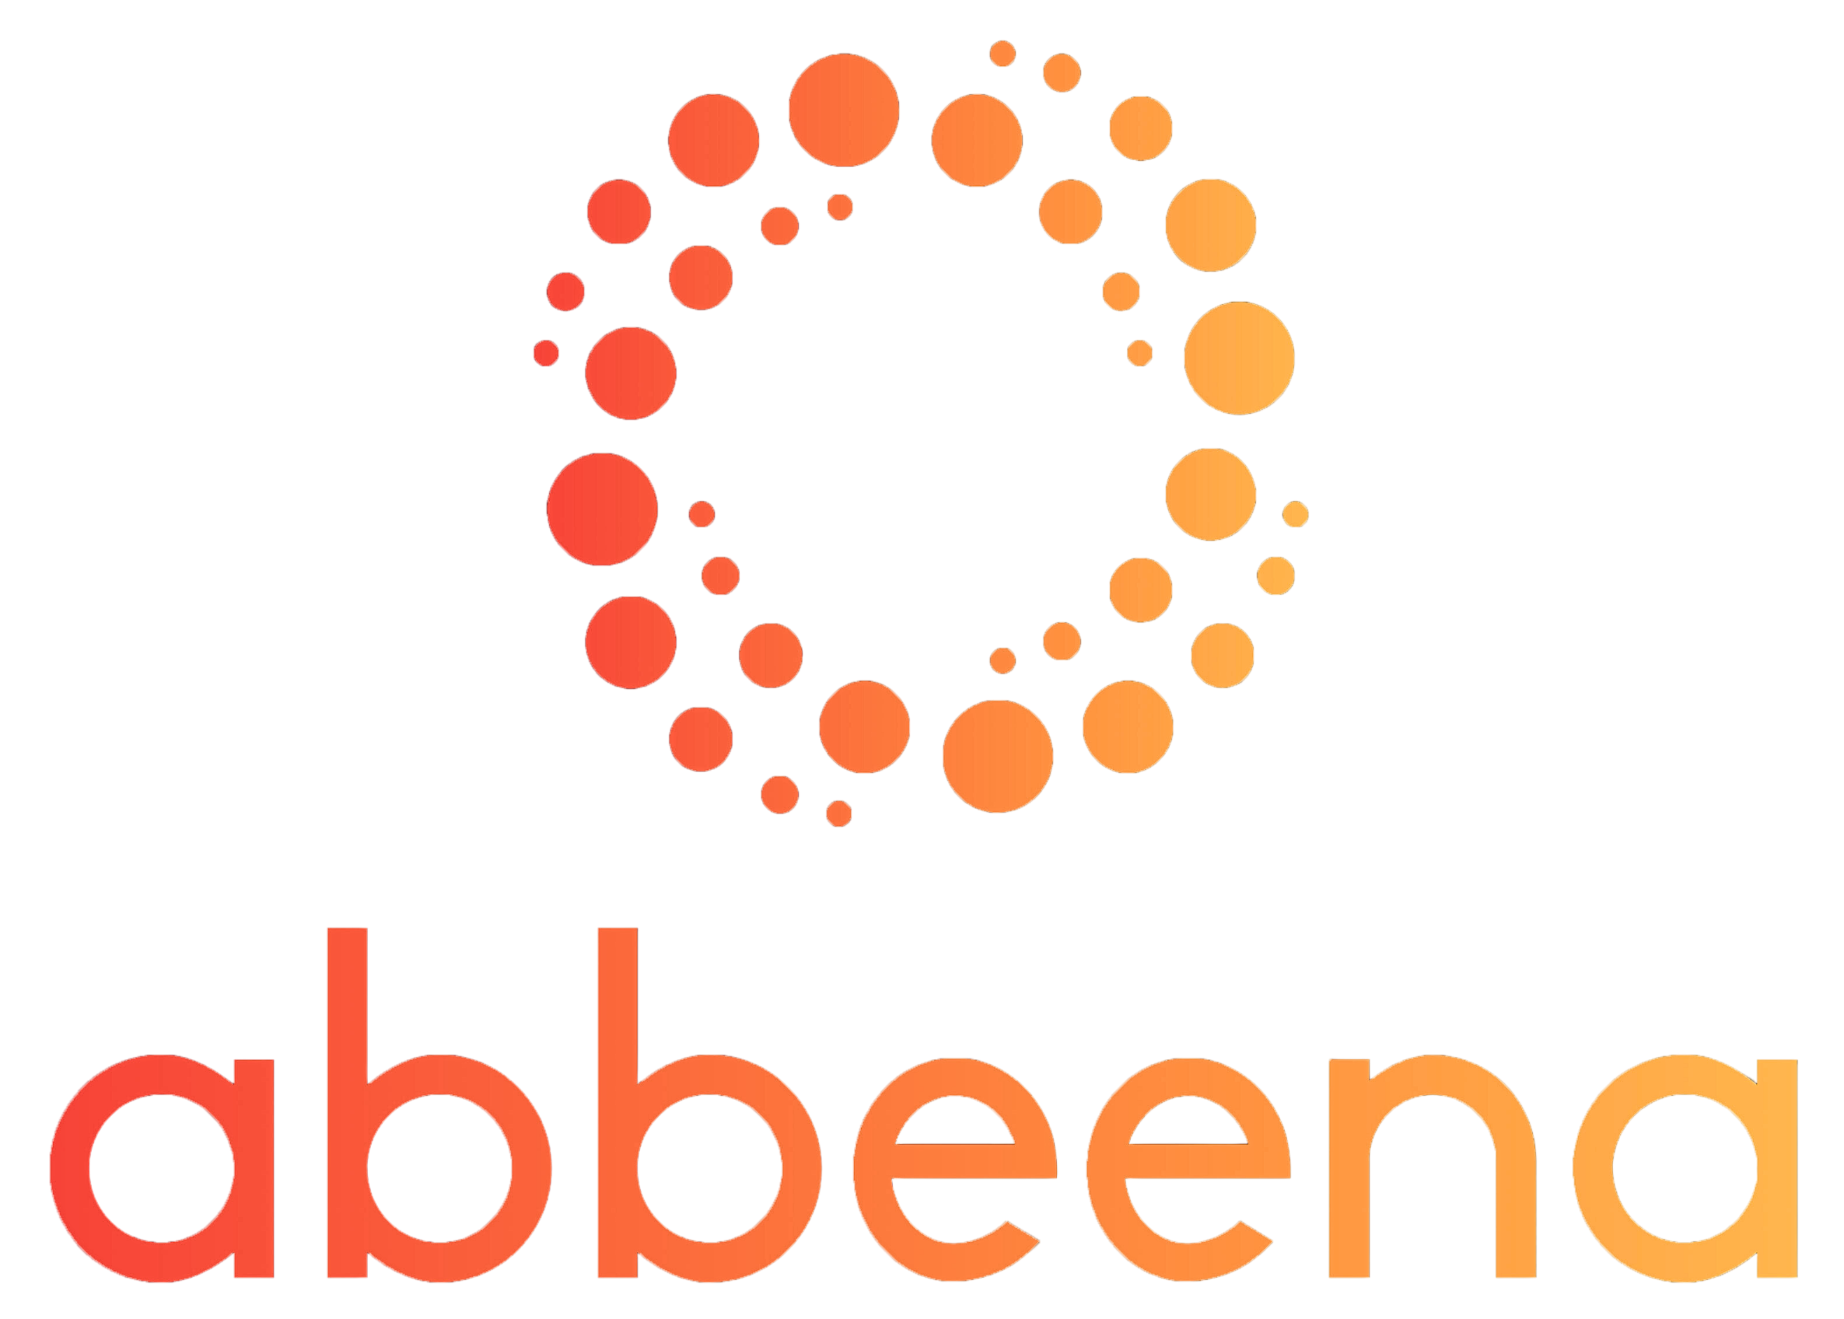Your Personal Plan Managers
 We have plan management capacity
 We’ll get you signed up within 24 hours
 Experience the benefits of a personal plan manager

www.providerchoice.com.au

Contact us anytime to find out more about what we
do and how we can help you on your NDIS journey.
Get in touch!

 accounts@abbeena.au
 02) 7245 2777

www.abbeena.au

